DIS-AM,C-Taino-Pendant-Manatee rib bone

Length: 4 in.

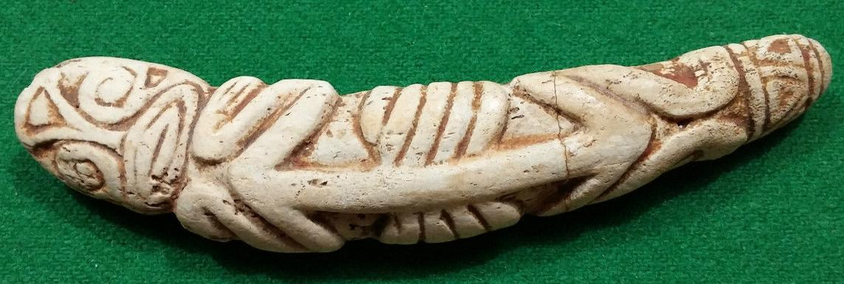

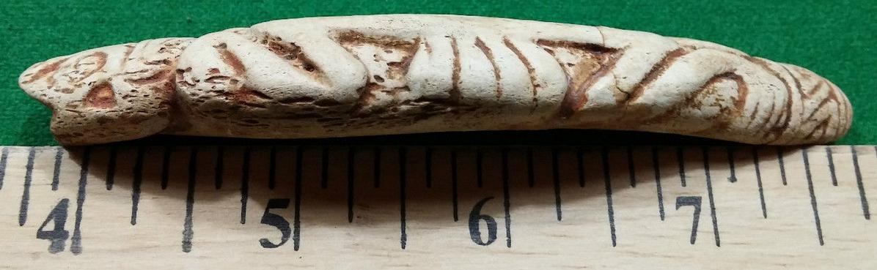

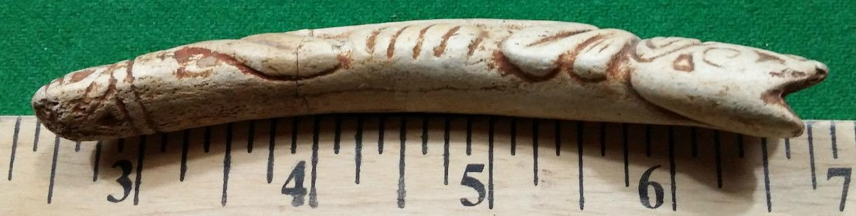

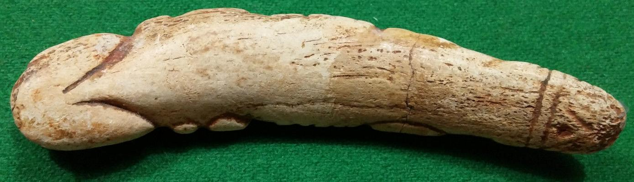

# Order details

## Sales order

Sold by [user1billion](http://myworld.ebay.com/user1billion) ( [791](http://feedback.ebay.com/ws/eBayISAPI.dll?ViewFeedback&userid=user1billion) )

### Delivery package 1 of 1

Estimated delivery Wednesday, Feb 3, 2016 - Wednesday, Feb 10, 2016

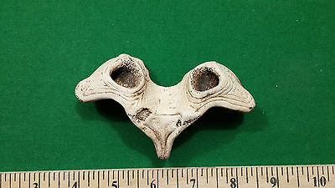

#### [Taino Pendent - Pre Columbian](http://www.ebay.com/itm/161947506881)

|  |  |
| --- | --- |
| Item price | $89.00 |
| Quantity | 1 |
| Item number | 161947506881 |
| Shipping service | Standard Int'l Shipping |

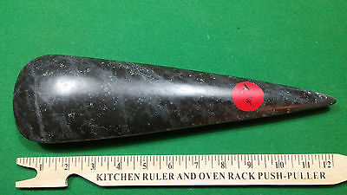

#### [Taino Stone Carving highly polished Cerimonial Axe](http://www.ebay.com/itm/272105571459)

|  |  |
| --- | --- |
| Item price | $199.00 |
| Quantity | 1 |
| Item number | 272105571459 |
| Shipping service | Standard Int'l Shipping |

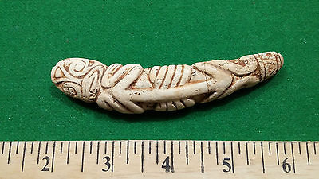

#### [Taino Carved Pendent - Pre Columbian](http://www.ebay.com/itm/272105659692)

|  |  |
| --- | --- |
| Item price | $129.00 |
| Quantity | 1 |
| Item number | 272105659692 |
| Shipping service | Standard Int'l Shipping |